**IPL DATASET ANALYSIS**

Que1…

readcsv in pandas

Cleaning 👍

Replacing boundary data with zero if there is null

Drop ***df_sbc = df_sbc.drop(['minutes','link','shortText','captain'], axis=1)***

Then group by (based on match_id , aggregation sum)

#per match score year-wise

**per_match_score = df_sbc.groupby(['season','match_id']). agg(Score=('runs', 'sum')) .reset_index()**

**per_match_score**

Aggregation (sum and mean match score year-wise)

# year-wise average score

**per_match_score.columns**

**per_match_score_season_wise = per_match_score.groupby(['season']).agg(Match_avg_score=('Score', 'mean')) .reset_index()**

**per_match_score_season_wise**

Then plotting them in bar graph

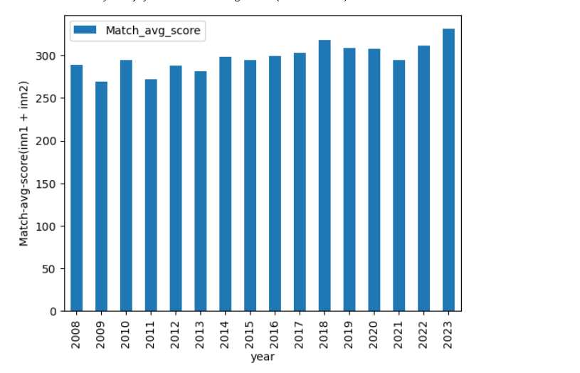

**Que2…**

Top batsman across the year (Boundary Count)

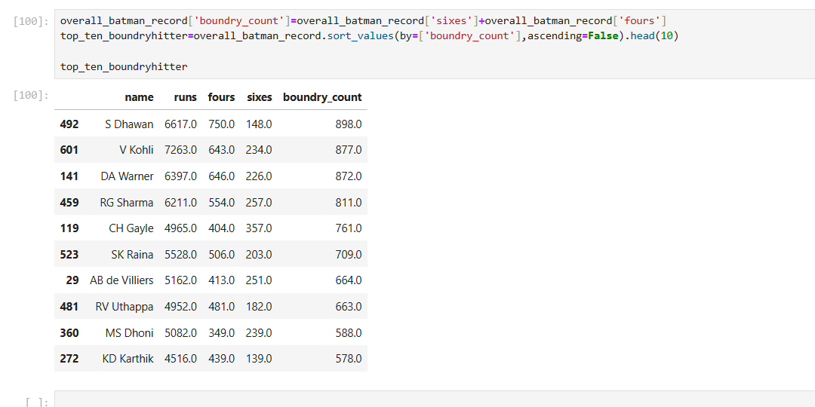

**Que3… Effective bowler**

Bowlers data : overs>150 and wickets>150 over the year

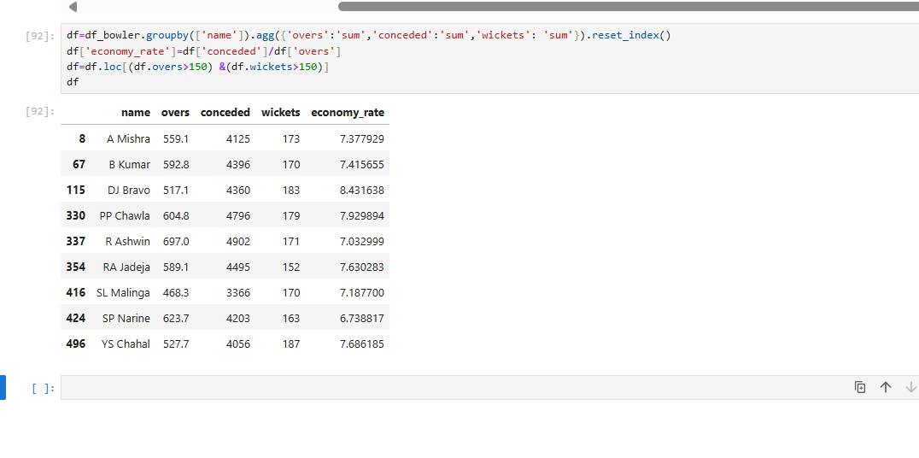

**Que 4**

**Top 5 batsman yearwise**

| season | name | season_total_score |
| --- | --- | --- |
| 2008 | SE Marsh | 616 |
| 2008 | G Gambhir | 534 |
| 2008 | ST Jayasuriya | 514 |
| 2008 | SR Watson | 472 |
| 2008 | GC Smith | 441 |
|  |  |  |
| 2009 | ML Hayden | 572 |
| 2009 | AC Gilchrist | 495 |
| 2009 | AB de Villiers | 465 |
| 2009 | SK Raina | 434 |
| 2009 | TM Dilshan | 418 |
|  |  |  |
| 2010 | SR Tendulkar | 618 |
| 2010 | JH Kallis | 572 |
| 2010 | SK Raina | 520 |
| 2010 | SC Ganguly | 493 |
| 2010 | M Vijay | 458 |
|  |  |  |
| 2011 | CH Gayle | 608 |
| 2011 | V Kohli | 557 |
| 2011 | SR Tendulkar | 553 |
| 2011 | SE Marsh | 504 |
| 2011 | MEK Hussey | 492 |
|  |  |  |
| 2012 | CH Gayle | 733 |
| 2012 | G Gambhir | 590 |
| 2012 | S Dhawan | 569 |
| 2012 | AM Rahane | 560 |
| 2012 | V Sehwag | 495 |
|  |  |  |
| 2013 | MEK Hussey | 733 |
| 2013 | CH Gayle | 708 |
| 2013 | V Kohli | 634 |
| 2013 | SK Raina | 548 |
| 2013 | SR Watson | 543 |
|  |  |  |
| 2014 | RV Uthappa | 660 |
| 2014 | DR Smith | 566 |
| 2014 | GJ Maxwell | 552 |
| 2014 | DA Warner | 528 |
| 2014 | SK Raina | 523 |
|  |  |  |
| 2015 | DA Warner | 562 |
| 2015 | AM Rahane | 540 |
| 2015 | LMP Simmons | 540 |
| 2015 | AB de Villiers | 513 |
| 2015 | V Kohli | 505 |
|  |  |  |
| 2016 | V Kohli | 973 |
| 2016 | DA Warner | 848 |
| 2016 | AB de Villiers | 687 |
| 2016 | G Gambhir | 501 |
| 2016 | S Dhawan | 501 |
|  |  |  |
| 2017 | DA Warner | 641 |
| 2017 | G Gambhir | 498 |
| 2017 | S Dhawan | 479 |
| 2017 | SPD Smith | 472 |
| 2017 | SK Raina | 442 |
|  |  |  |
| 2018 | KS Williamson | 735 |
| 2018 | RR Pant | 684 |
| 2018 | KL Rahul | 659 |
| 2018 | AT Rayudu | 602 |
| 2018 | SR Watson | 555 |
|  |  |  |
| 2019 | DA Warner | 692 |
| 2019 | KL Rahul | 593 |
| 2019 | Q de Kock | 529 |
| 2019 | S Dhawan | 521 |
| 2019 | AD Russell | 510 |
|  |  |  |
| 2020 | KL Rahul | 670 |
| 2020 | S Dhawan | 618 |
| 2020 | DA Warner | 548 |
| 2020 | SS Iyer | 519 |
| 2020 | Ishan Kishan | 516 |

**Que 5**

**Top 5 Hitter Batsmen**

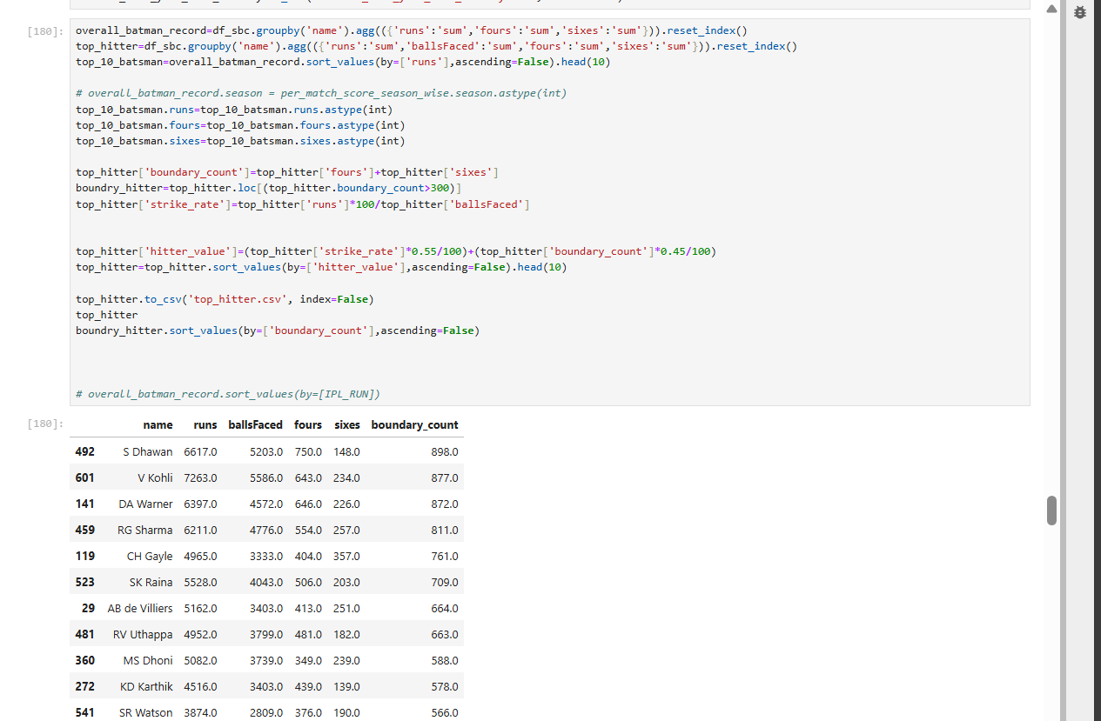

Created a column named hitter_ratio

Equals to=(top_hitter['strike_rate']*0.55/100)+(top_hitter['boundary_count']*0.45/100)

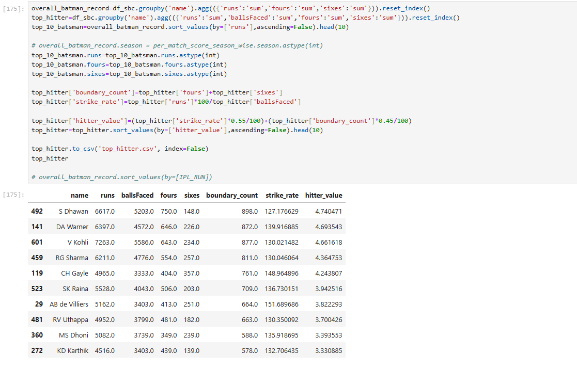

**EXTRA**

Top 5 Bowlers of all season

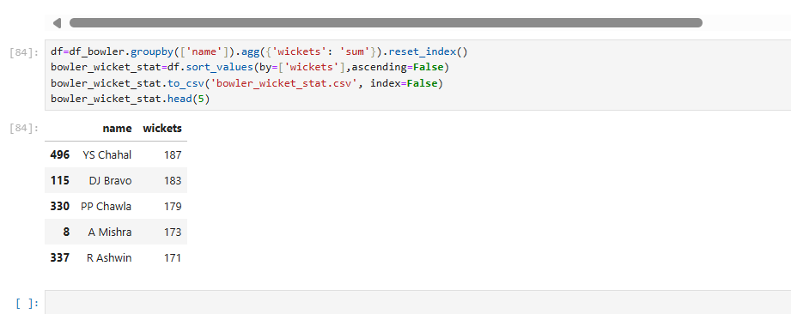

Top batsman across the year (run score)

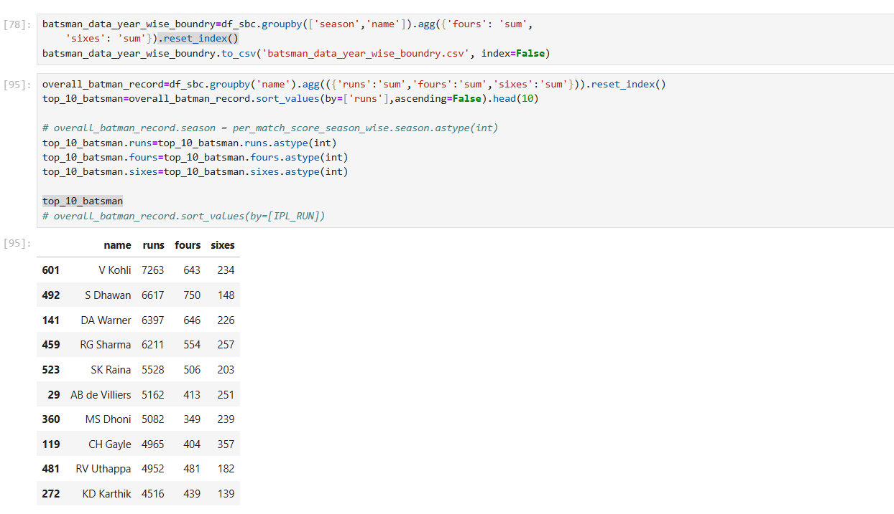

The Year's Top 5 Batsmen

Using Google Sheets' Advanced Sort & Filter Option, I first sorted the top scorers annually before selecting the top 5 boundary makers from each category.Filter functions had to be used to filter the data because certain values were disrupting the dataset.

* Shubman Gill scored the most runs with 118, followed by YBK Jaiswal with 108.
* Shubman Gill hit the most fours with 85, while YBK Jaiswal hit 82.
* JC Buttler hit the most sixes with 45, followed by F du Plessis with 36.
* JC Buttler had the highest total boundaries with 128, followed by Shubman Gill with 118.

Overall, Shubman Gill and JC Buttler were the standout performers in the 2023 season, with impressive performances in terms of runs scored, boundaries hit, and consistency.

Batsman Having strike rate >150 and total ipl run>2000 over the year

* **Strong candidates for IPL11**

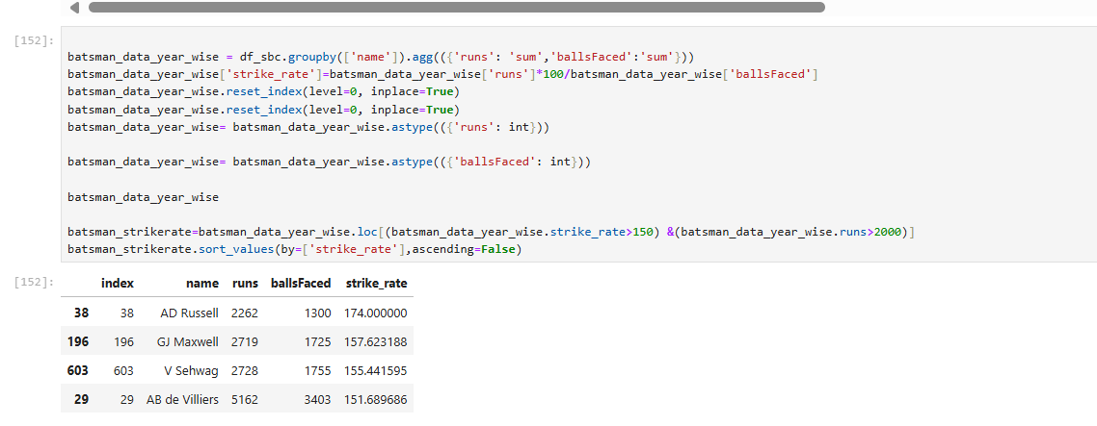

**IPL11**

| **ROHIT SHARMA** | | |
| --- | --- | --- |
| **VIRAT KOHLI** | | |
| **SHIKHAR DHAWAN** | | |
| **CHRIS GAYLE** | | |
| **AB DEVELIES** | | |
| **ANDRE RUESSEL** | | |
| **MS DHONI** | | |
| **Y CHAHAL** | | |
| **DJ BRAVO** | | |
| **PIYUSH CHAWLA** | | |
| **LASITH MALINGA** | | |